Tasks on Terraform-01
1) Install Terraform on your PC

Steps To Install Terraform on Windows 10 or 8 or 7

1) Download Terraform
https://www.terraform.io/downloads.html
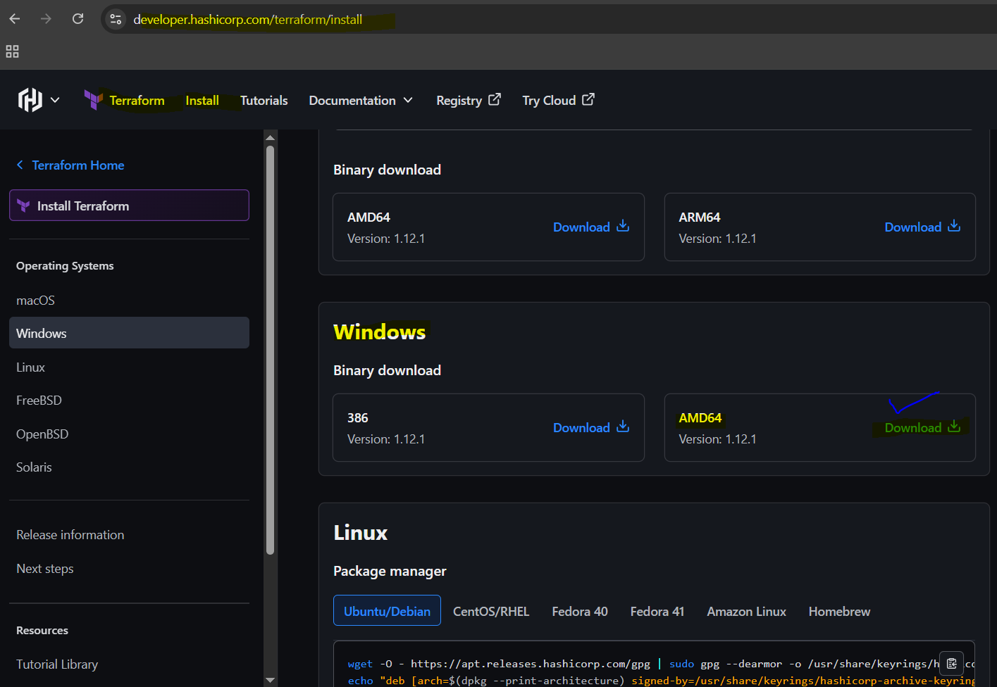
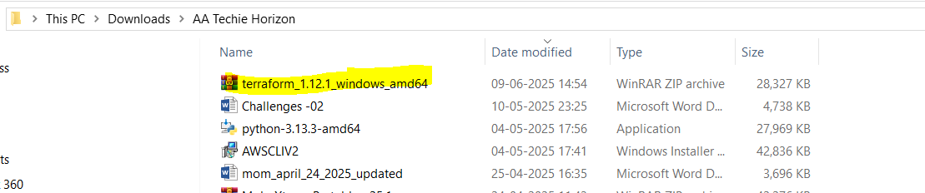

2) Unzip the terraform package
Extract the downloaded zip file, after extracting the zip file you can see terraform.exe file.
Extracted path can be Example " C:\Users\DevOps\Terraform "
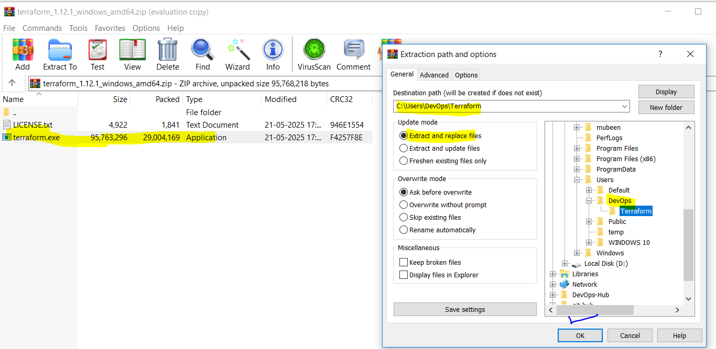
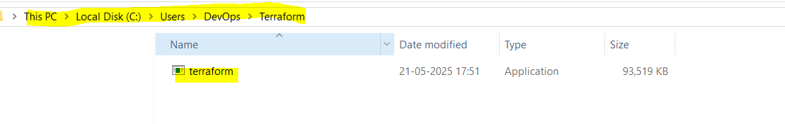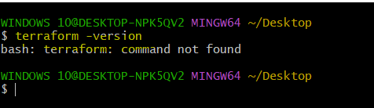

3) Configure environment variables for terraform
system variables—>path–edit–>new
paste the path "C:\Users\DevOps\Terraform”
Click on Ok.
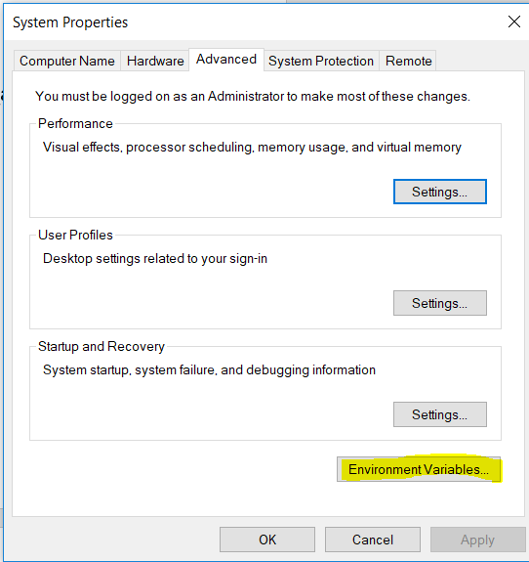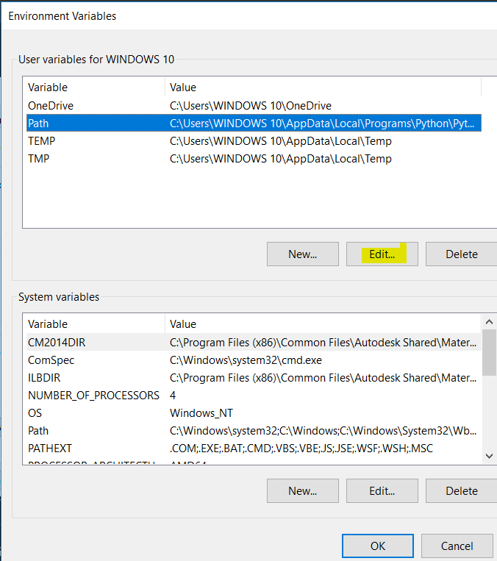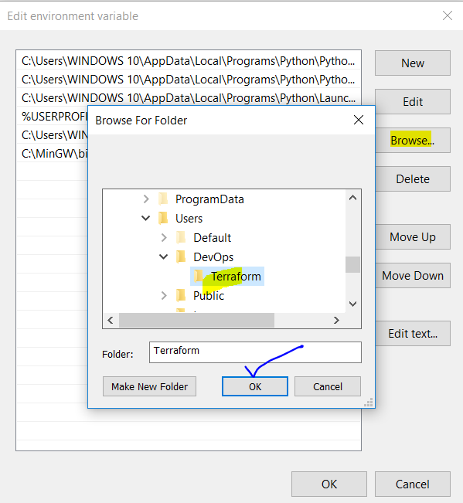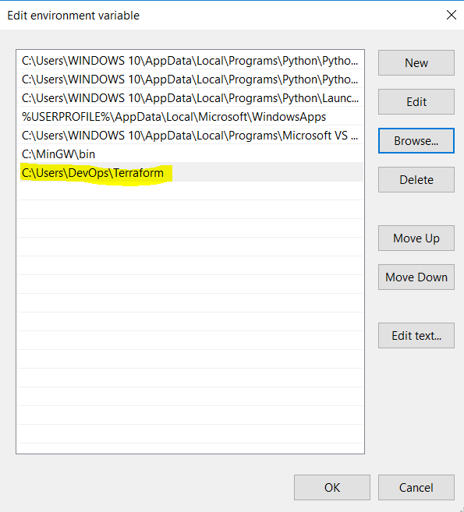

4) Verify terraform version
Open gitbash and enter
> terraform -version
Terraform v1.12.1
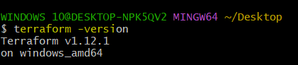

2) Execute all the templates shown in video.

First we need to do some Visual studio code setup.
Created new Folder as Terraform and created new file in it main.tf.
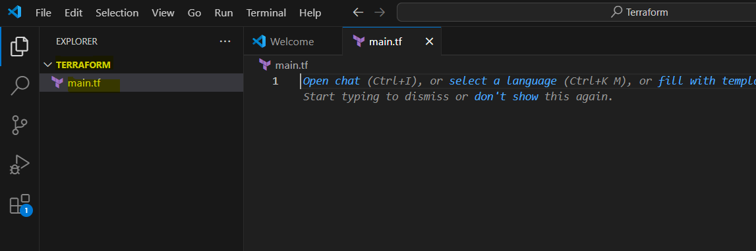
Installing the Extension Hashicorp Terraform. It will help to create Template easily.
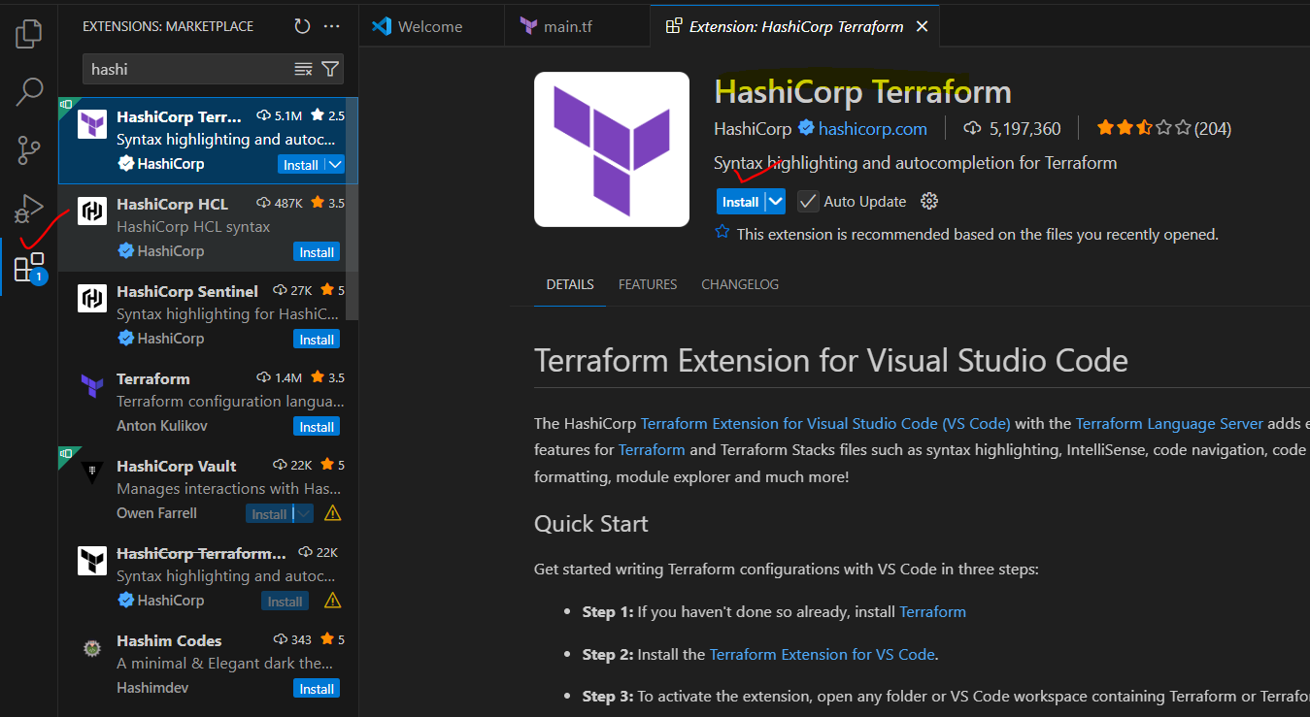
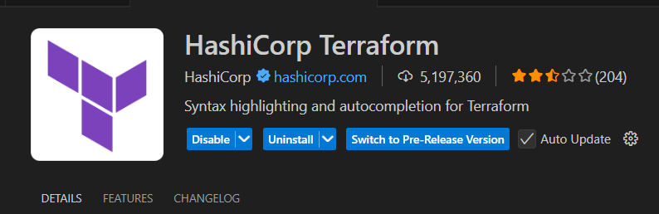
Template-01: Using Local provider, type as a file.
resource "local_file" "my_avengers" {
filename = "Avengers.txt"
content = "I like to watch it!"
}

Using VSC terminal.

terraform init – To initiate Terraform, it will download all dependencies and .terraform hidden directory is also created.
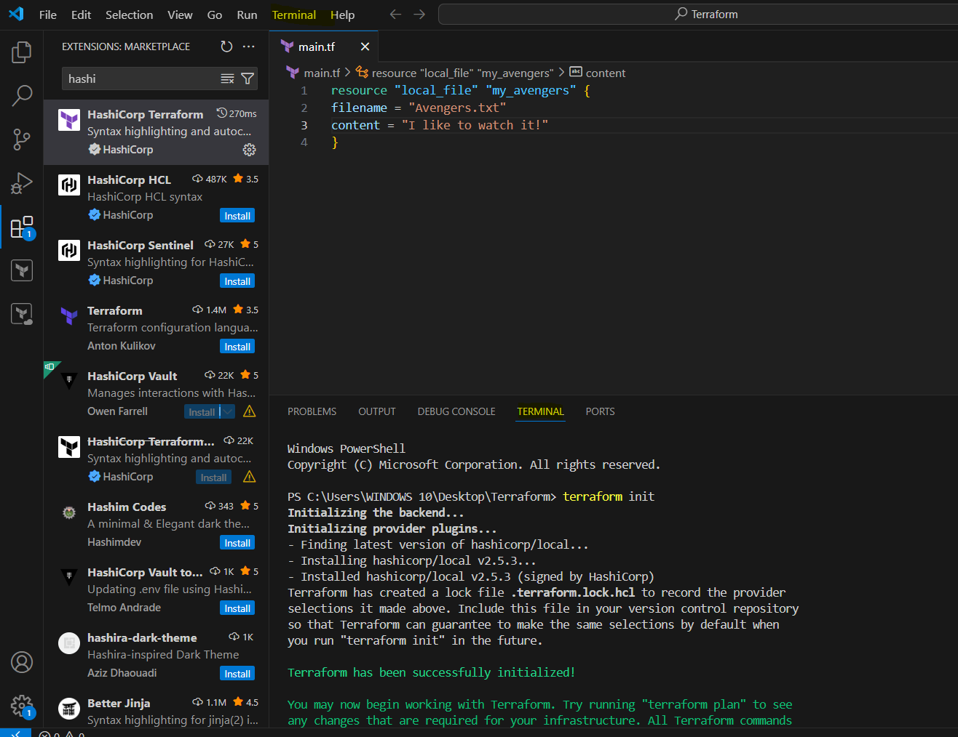

terraform plan – It is a Blueprint which will helps us to understand how the template will be executed.

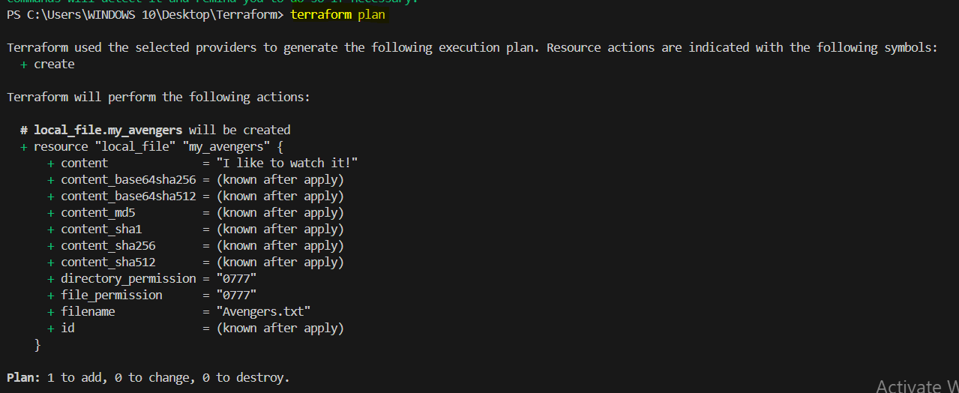

terraform apply – To execute the template.
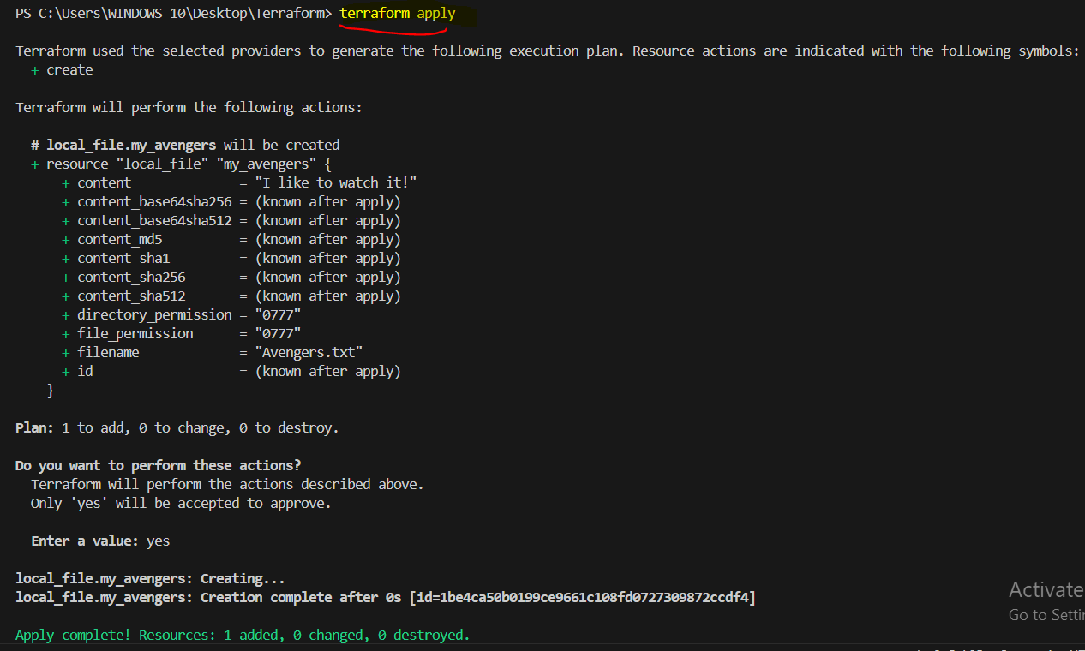
New file is created.
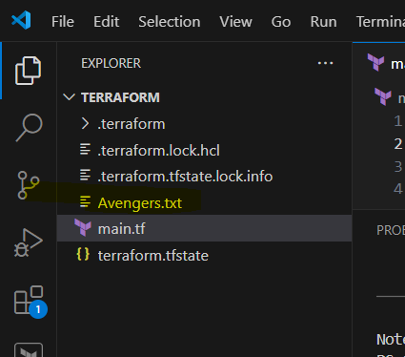

Making changes in the content of the template and executing the script again. Looking for plan and output.
resource "local_file" "my_avengers" {
filename = "Avengers.txt"
content = "I don't like to watch it!"
}

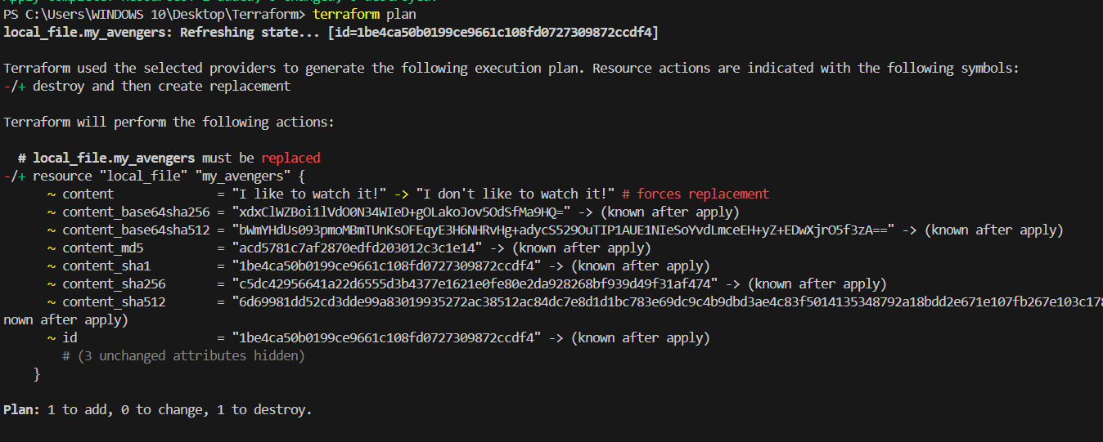

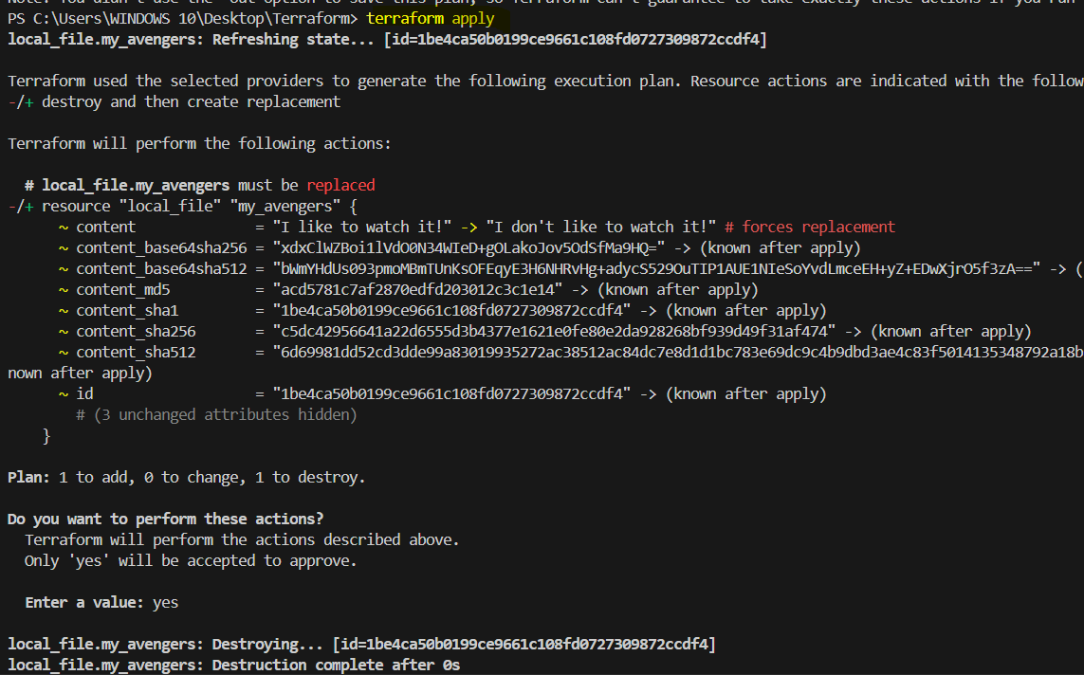

Changed output.
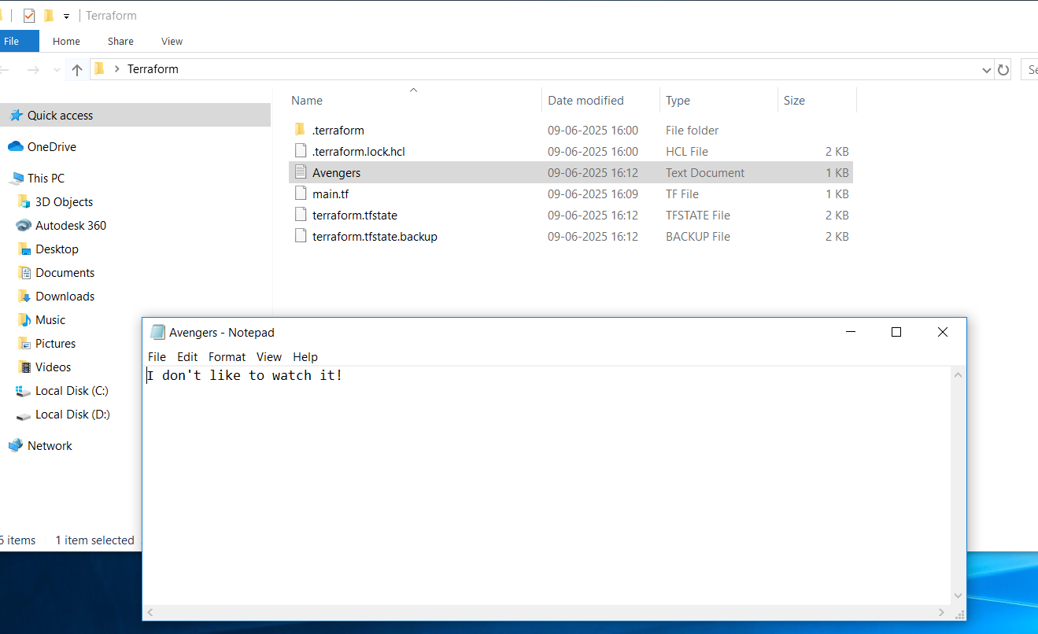

Template 02: Executing Multi providers local and random as provider and pet as type.
resource "local_file" "my_avengers" {
filename = "Avengers.txt"
content = "I don't like to watch it!"
}
resource "random_pet" "myavengres" {
prefix = "Master"
separator = "."
length = "1"
}

If we see this error need to initialise again.
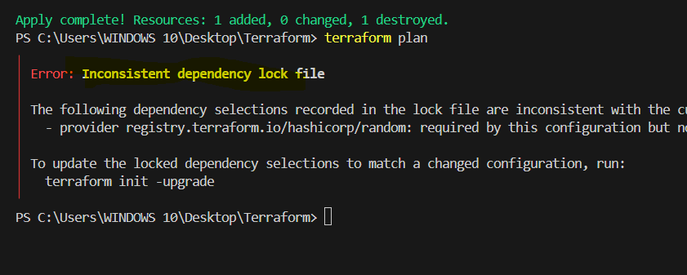

terraform init -upgrade – To initiate Terraform, it will download all dependencies and .terraform hidden directory is also created.
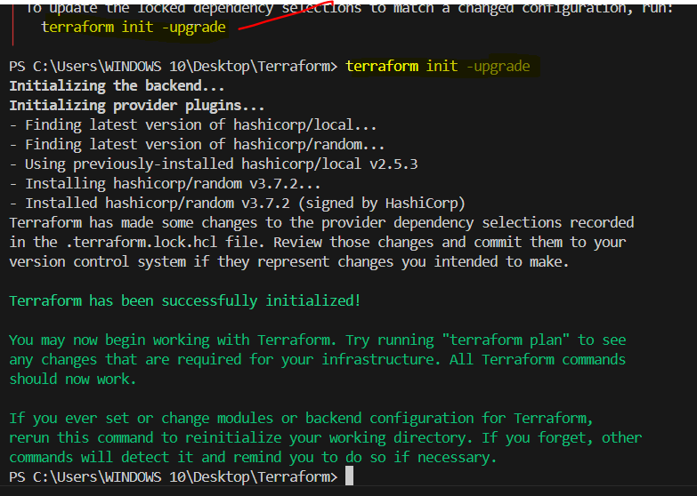
terraform plan – It is a Blueprint which will helps us to understand how the template will be executed.

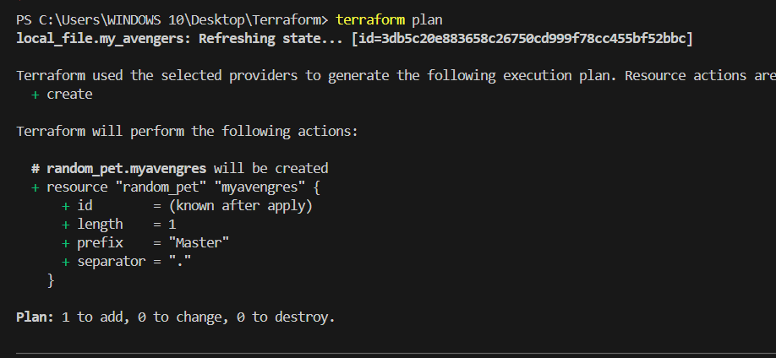

terraform apply – To execute the template.

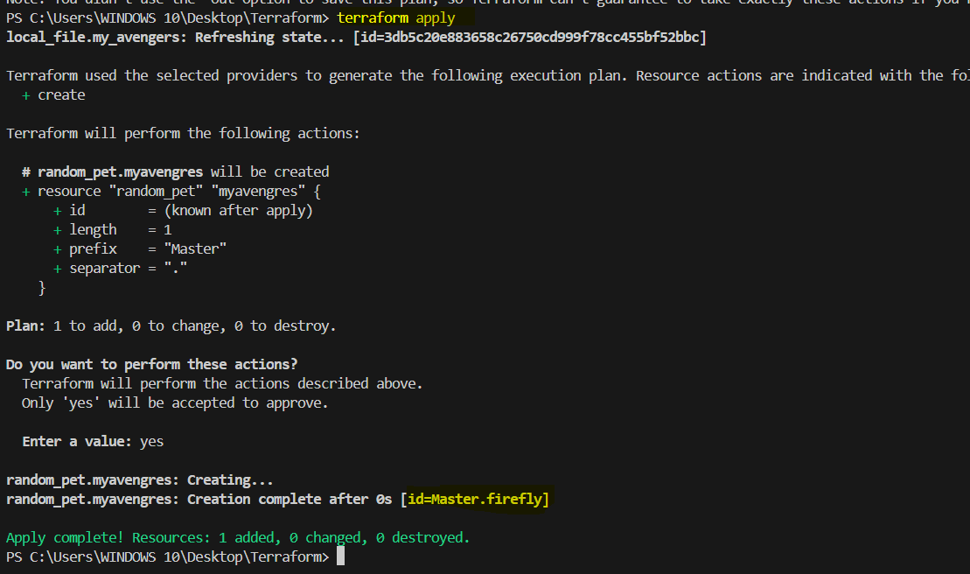

Random id=Master.firefly is created.
terraform fmt - To fix the format.
Before:
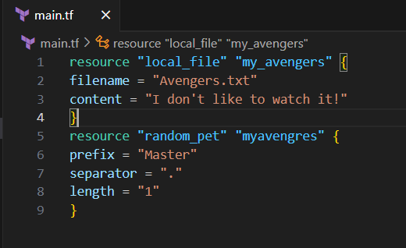

After:
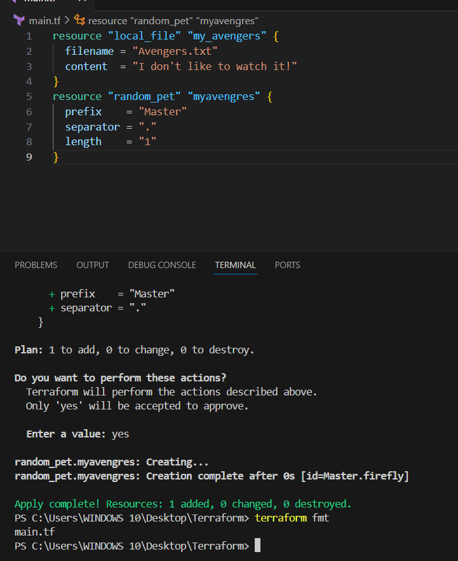

terraform destroy – To systematically and safely remove all infrastructure resources.
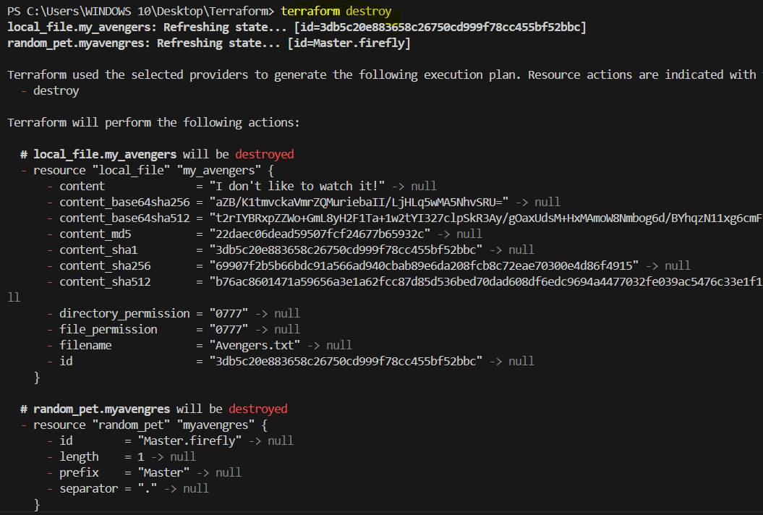

3) Note down below points, Terraform Init, Terraform Plan, Terraform Apply, Terraform Provider.

Terraform Init (terraform init):
terraform init is the foundational command to prepare your Terraform working directory. When executed, it first downloads and installs all necessary provider plugins (e.g., for AWS, Azure, Google Cloud) that are declared in your configuration files, fetching them from the Terraform Registry. Simultaneously, it initializes the chosen backend, which is crucial for storing and managing your Terraform state file, mapping your configuration to real-world infrastructure. If your project uses external modules, init will also download and configure those. Essentially, it's the essential setup step that ensures Terraform has all the necessary components to interact with your target environment and manage your infrastructure effectively, making your configuration runnable for subsequent commands.

Terraform Plan (terraform plan):
terraform plan provides a critical "dry run" of your infrastructure changes, acting as a vital safety net before any actual modifications. It begins by meticulously analyzing your Terraform configuration files (.tf) to understand your desired infrastructure state. This desired state is then compared against the current actual state of your deployed resources, which Terraform determines by consulting its state file and, if necessary, querying the live cloud environment. From this comparison, Terraform intelligently generates a detailed execution plan, outlining every specific action (create, update, or destroy) required to reconcile the differences. This comprehensive plan is then outputted to your console, allowing you to thoroughly review and verify all proposed changes, preventing unintended infrastructure modifications or errors.

Terraform Apply (terraform apply):
terraform apply is the command that executes the plan generated by terraform plan, making real-world changes to your infrastructure. Upon execution, it typically prompts for explicit user confirmation (unless overridden with -auto-approve), ensuring that you consciously approve the deployment. Terraform then sends the necessary API calls to the respective cloud providers (or other services) via their dedicated provider plugins, orchestrating the creation, modification, or deletion of resources as detailed in the approved plan. Throughout this process, Terraform continuously updates its state file, ensuring it accurately reflects the current status of your managed infrastructure. The successful outcome is your cloud resources being provisioned or updated precisely according to your Terraform configuration, with the state file now perfectly synchronized.
Terraform Provider:
A Terraform provider is a fundamental plugin that serves as the essential bridge between your Terraform configuration and a specific API of a service, whether it's a cloud platform, SaaS application, or on-premises system. Its core purpose is to enable Terraform to understand and manage resources within that service as code. Providers achieve this by defining a schema for various resource types (like aws_instance or azurerm_resource_group) and data sources, and then handling the translation of your declarative configuration into the precise API calls required to perform CRUD (Create, Read, Update, Delete) operations on those resources. There are various types of providers, including dominant Cloud Providers (AWS, Azure, GCP), SaaS Providers (GitHub, Datadog), On-Premises/Virtualization Providers (vSphere), and specialized Network/Security or Utility Providers. We can check at Terraform Registry.
4) Integrate a sample Terraform template in jenkins.

Prerequisites:
Jenkins is installed and running. (Already available):
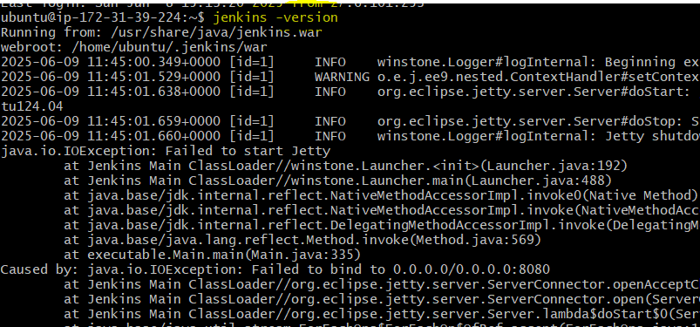
Terraform is installed. (Need to be installed):
sudo apt update && sudo apt upgrade -y
Updates package lists and upgrades existing packages to avoid compatibility issues.
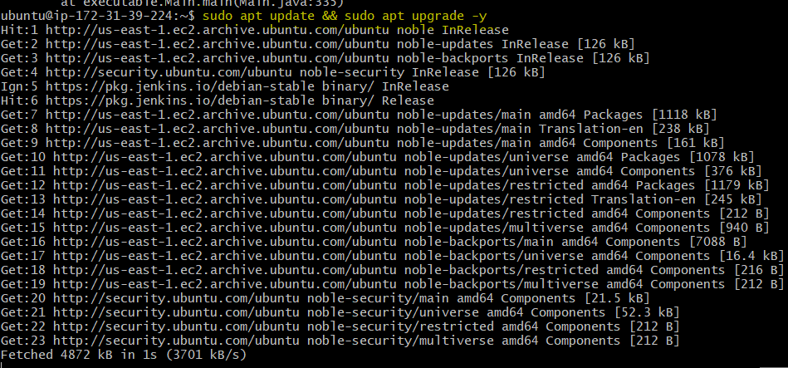

sudo apt install -y gnupg software-properties-common curl
Installs required tools for adding secure external repositories and downloading keys.
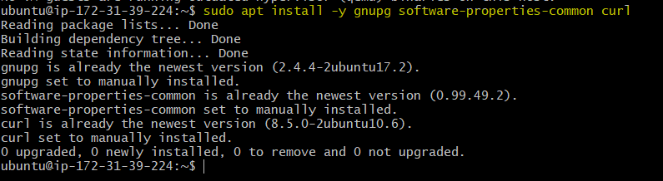

curl -fsSL https://apt.releases.hashicorp.com/gpg | sudo gpg --dearmor -o /usr/share/keyrings/hashicorp-archive-keyring.gpg
Adds HashiCorp's GPG key securely to verify Terraform package authenticity.

echo "deb [signed-by=/usr/share/keyrings/hashicorp-archive-keyring.gpg] https://apt.releases.hashicorp.com $(lsb_release -cs) main" | \
sudo tee /etc/apt/sources.list.d/hashicorp.list
Adds HashiCorp's official repository to your APT sources list for Terraform packages.

sudo apt update
Refreshes package list to include new HashiCorp repository.
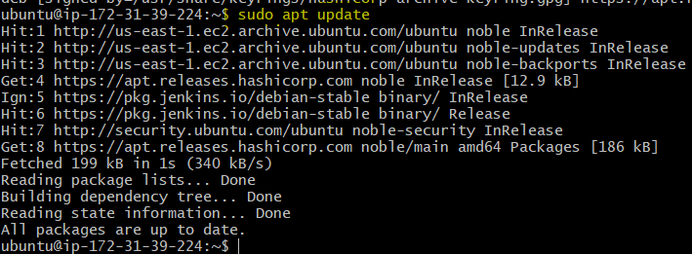

sudo apt install terraform -y
Installs the latest Terraform CLI from HashiCorp's official repository.
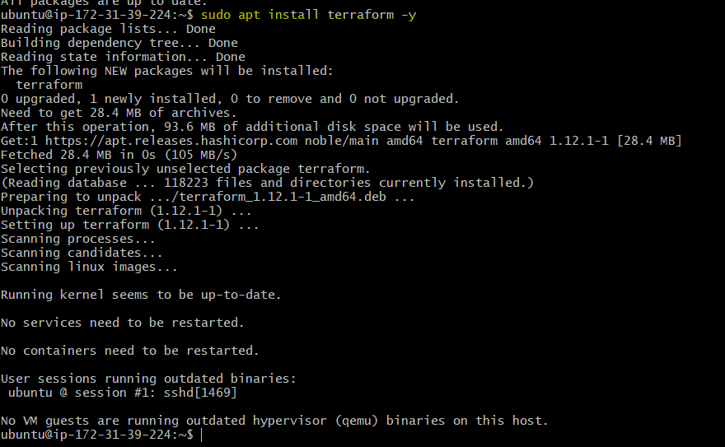

terraform -v
Verifies that Terraform was installed successfully and displays the version.
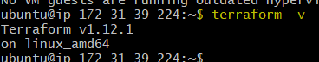

A Git repository contains your Terraform code:
Create a Git repo with a file called main.tf and Jenkins file.

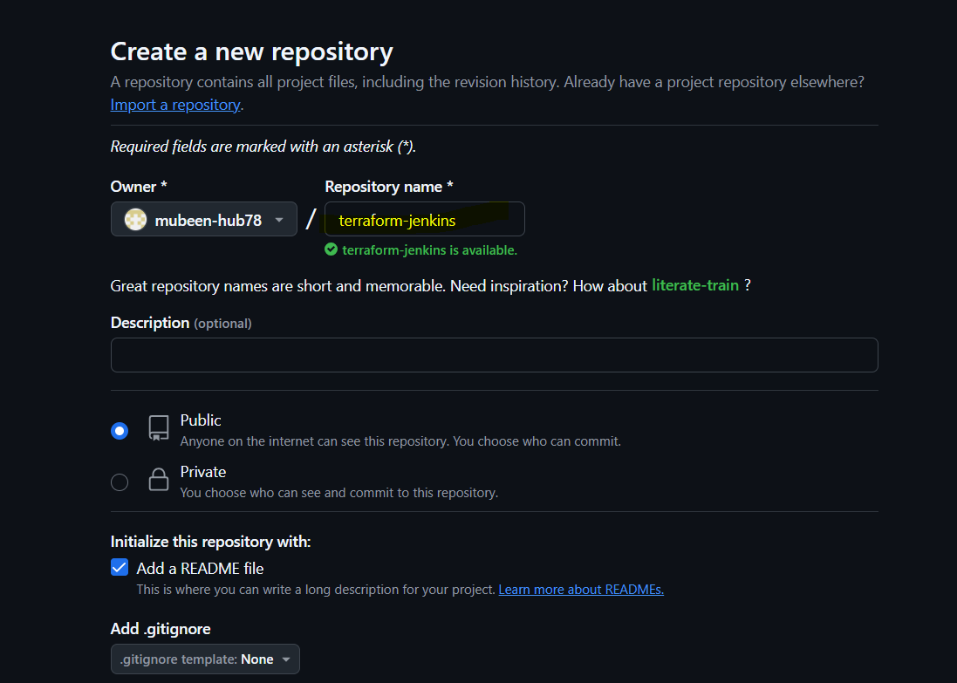
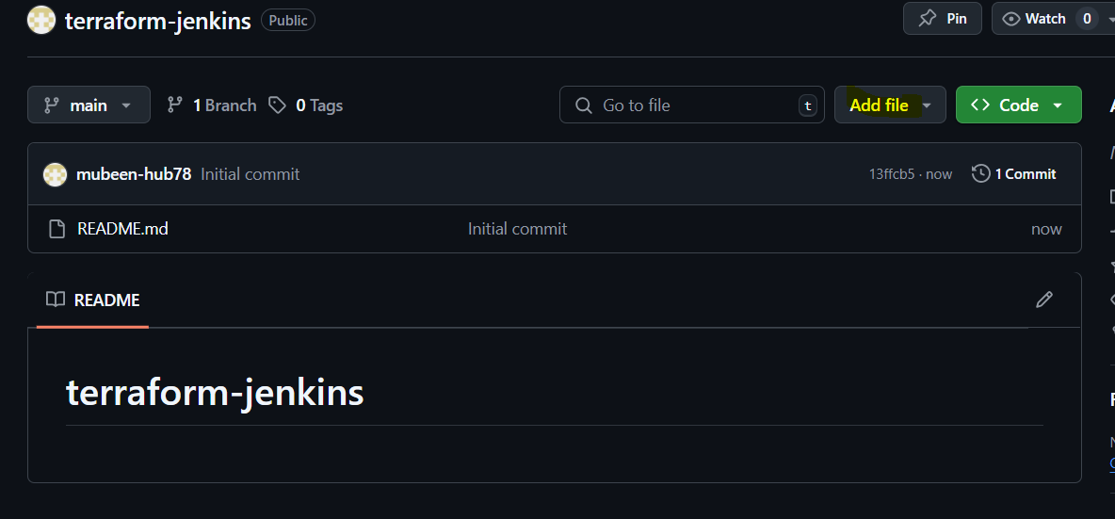
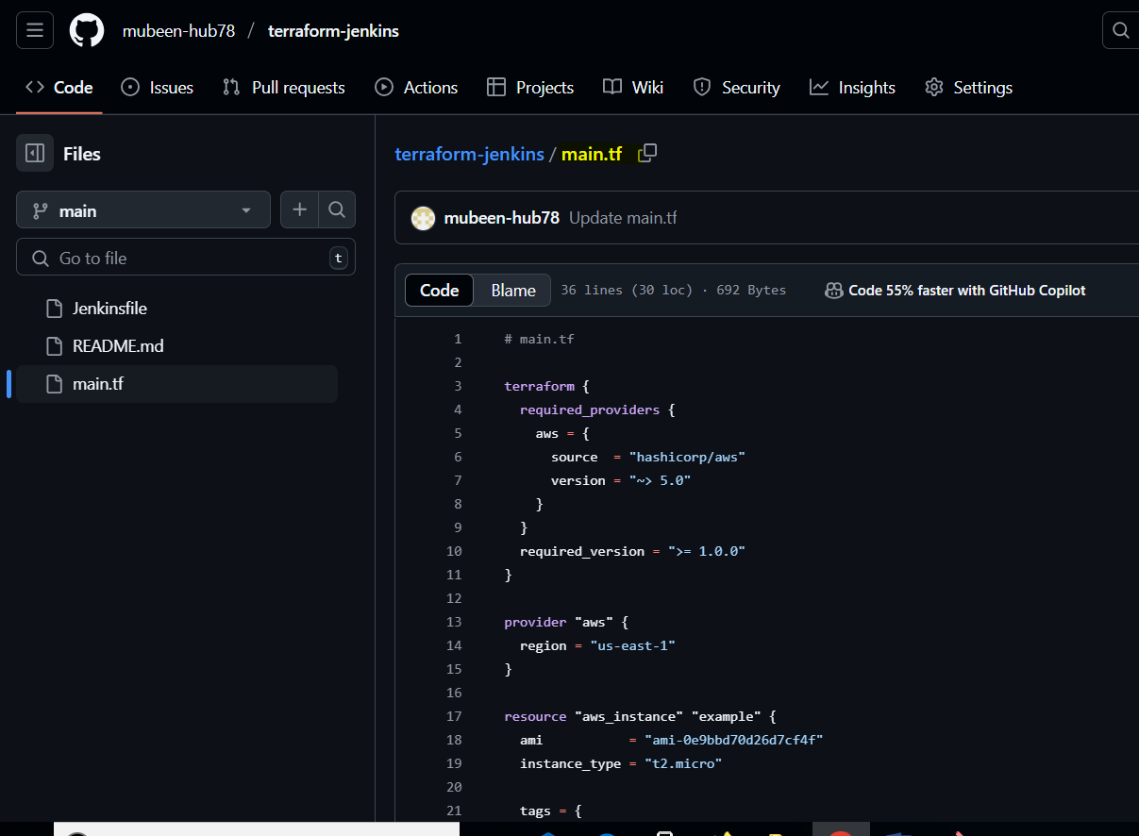
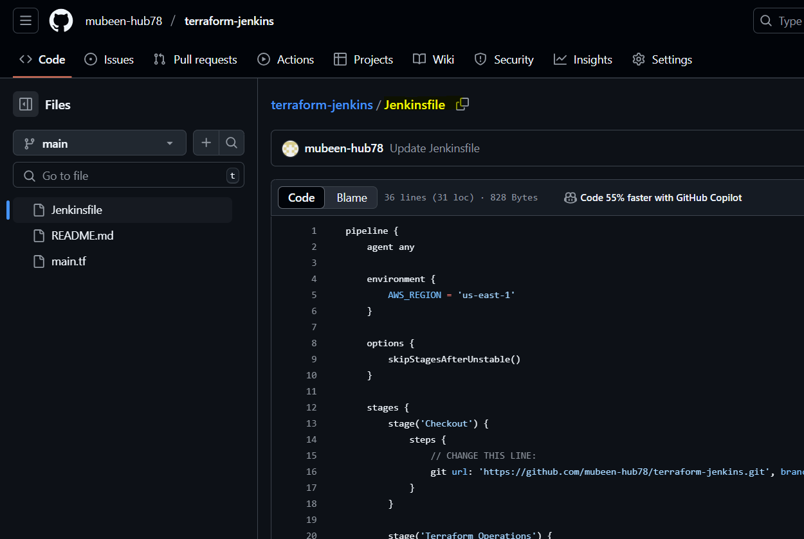

AWS CLI credentials are set up using credentials in Jenkins:
Add Aws credentials plugin in Jenkins.
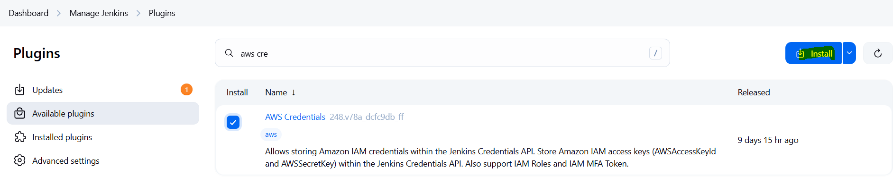

Create Aws credentials with the used having Full EC2 Access.
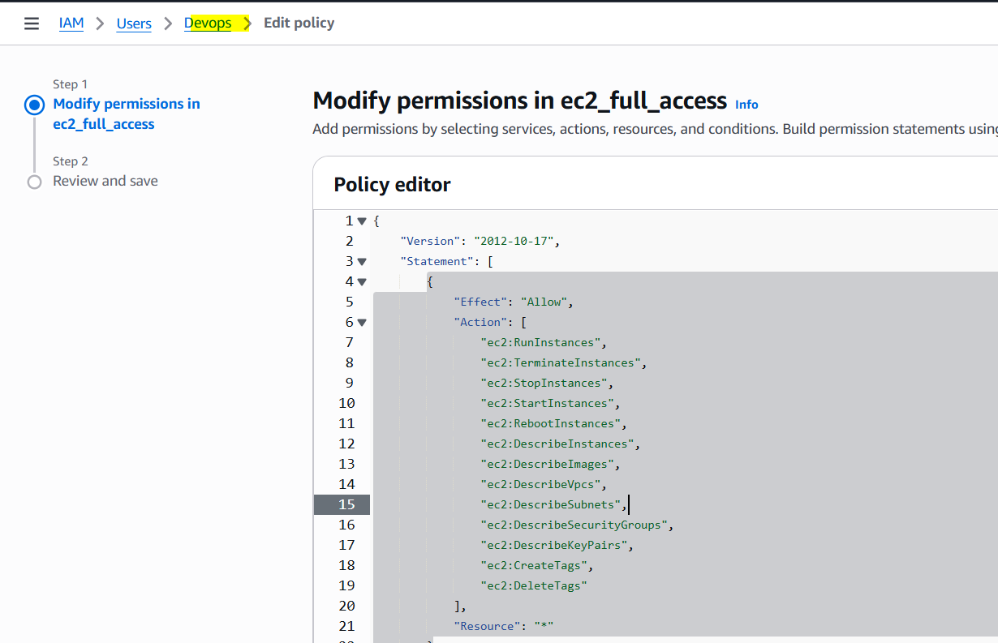
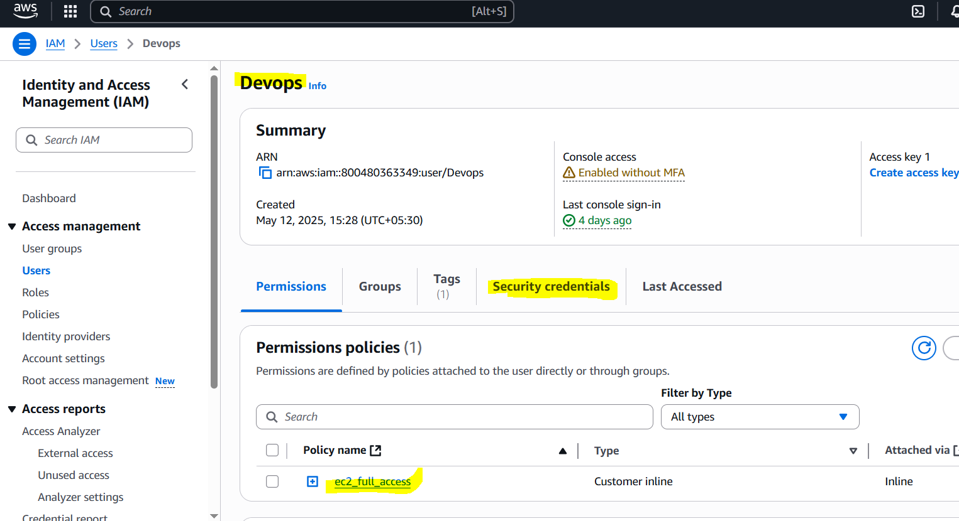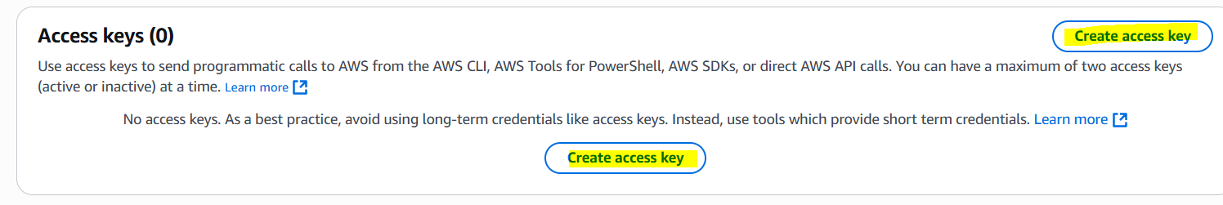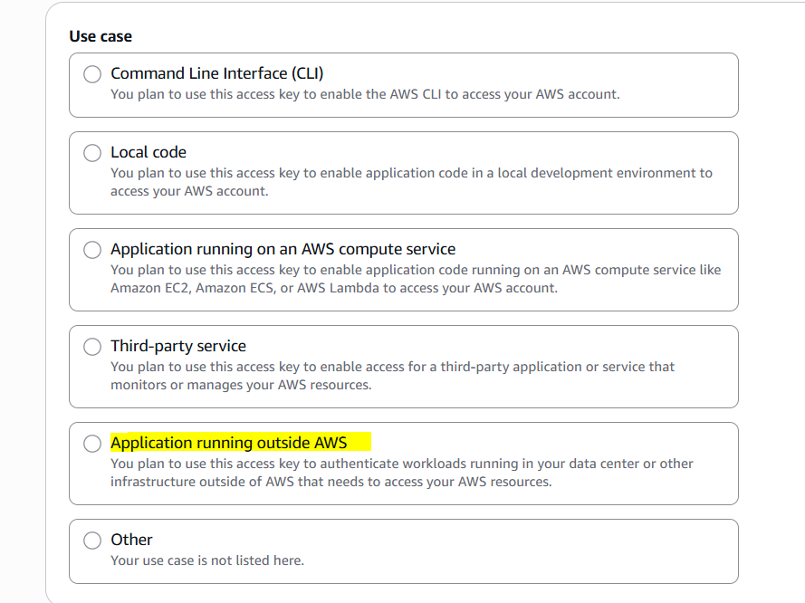
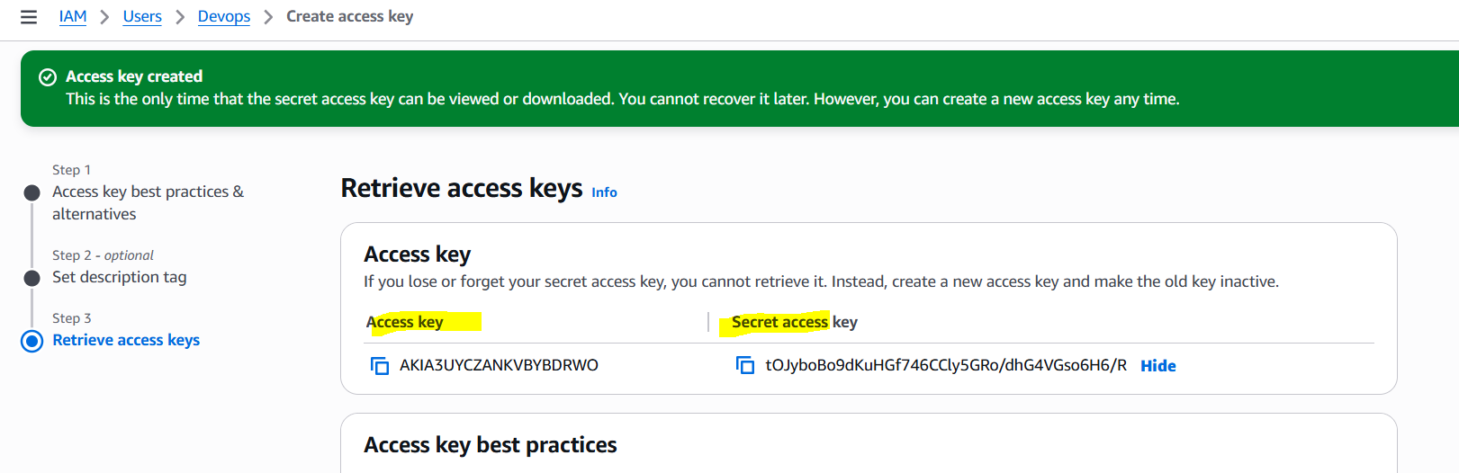

Now we have to add these keys in Credentials of Jenkins.
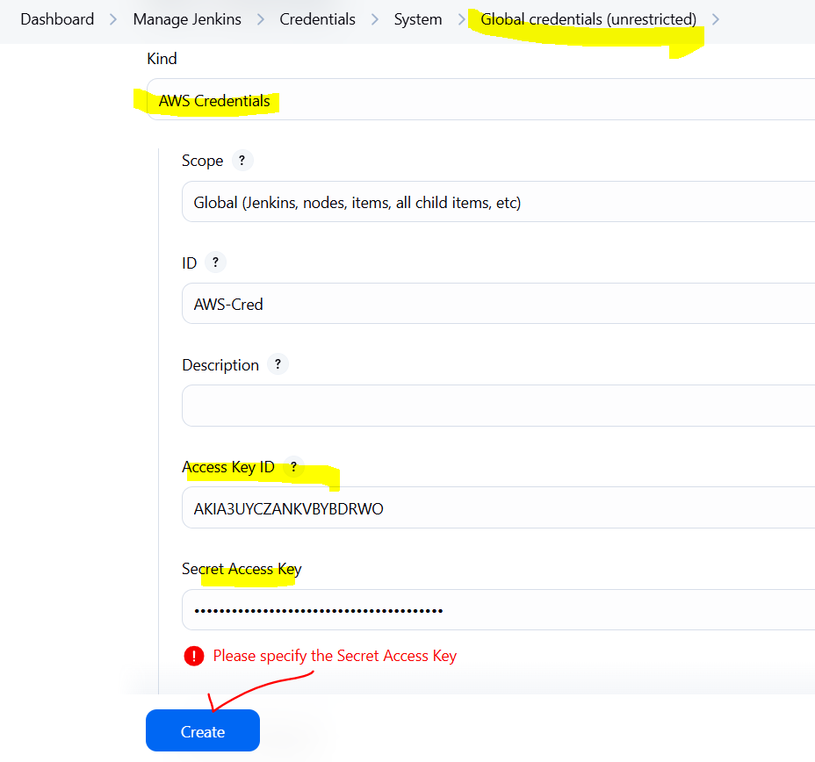

Create a Job for terraform.
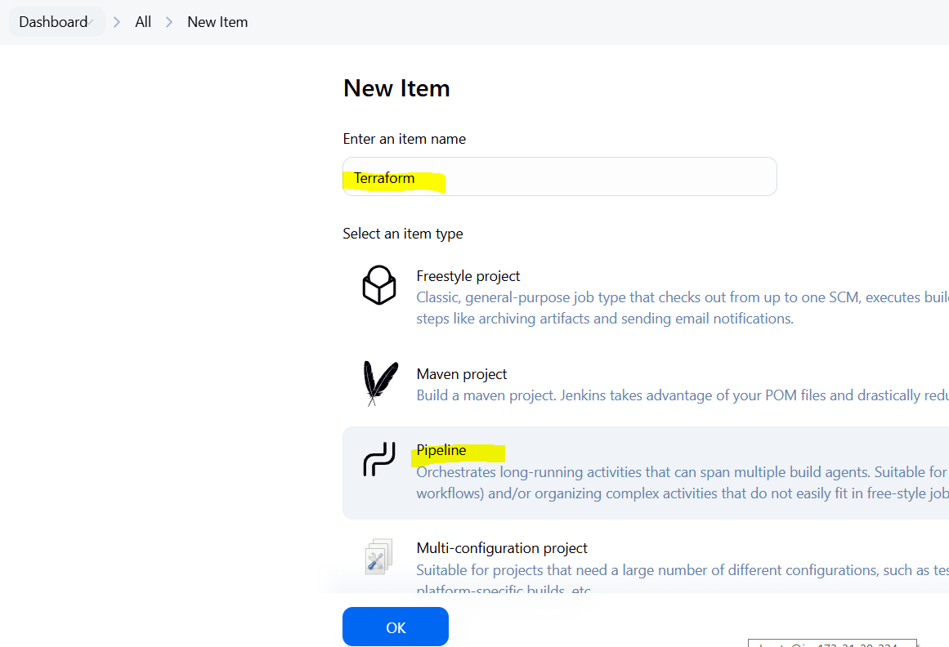
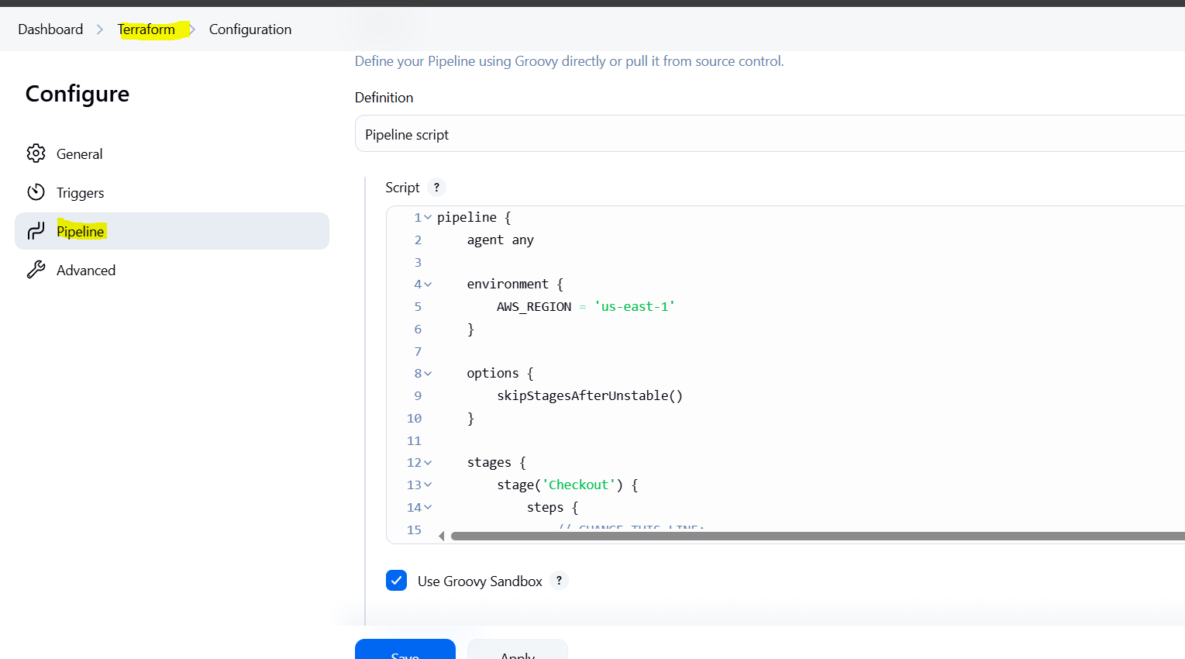

Add this pipeline.

pipeline {
agent any

environment {
AWS_REGION = 'us-east-1'
}

options {
skipStagesAfterUnstable()
}

stages {
stage('Checkout') {
steps {
// CHANGE THIS LINE:
git url: 'https://github.com/mubeen-hub78/terraform-jenkins.git', branch: 'main' // Assuming 'main' branch
}
}

stage('Terraform Operations') {
steps {
withCredentials([[$class: 'AmazonWebServicesCredentialsBinding', credentialsId: 'AWS-Cred']]) {
sh 'terraform init'
sh 'terraform plan -out=tfplan'
sh 'terraform apply -auto-approve tfplan'
}
}
}
}

post {
always {
cleanWs()
}
}
}

Explanation:

Step 1: Start the Pipeline
Jenkins starts the pipeline and chooses an available build machine.
It sets the AWS region as us-east-1.
A temporary workspace folder is created to run the job.

Step 2: Checkout the Code
Jenkins pulls your code from GitHub (like main.tf and Jenkinsfile) into the workspace.

Step 3: Run Terraform Commands
Jenkins securely loads your AWS credentials.
It runs terraform init to set up Terraform and download plugins.
It runs terraform plan to check what will be created on AWS.
It runs terraform apply to create the actual resources like an EC2 instance.

Step 4: Cleanup
Jenkins deletes the workspace folder after the job to save space.

Step 5: Finish the Pipeline
Jenkins shows if the job succeeded or failed based on the commands.

Run the job.
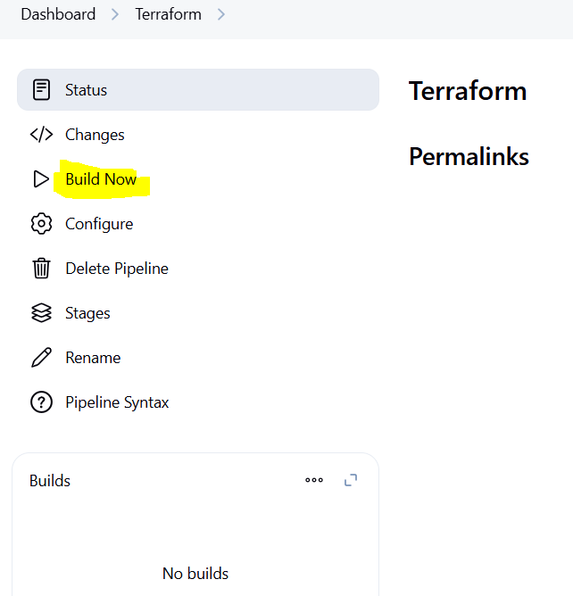
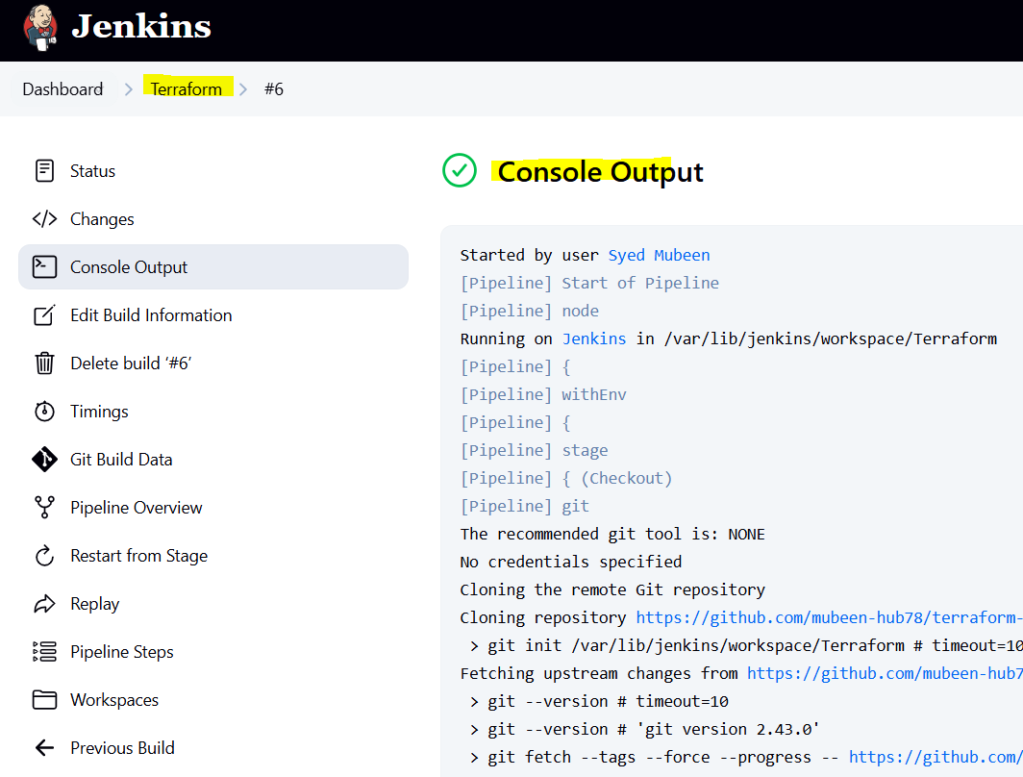
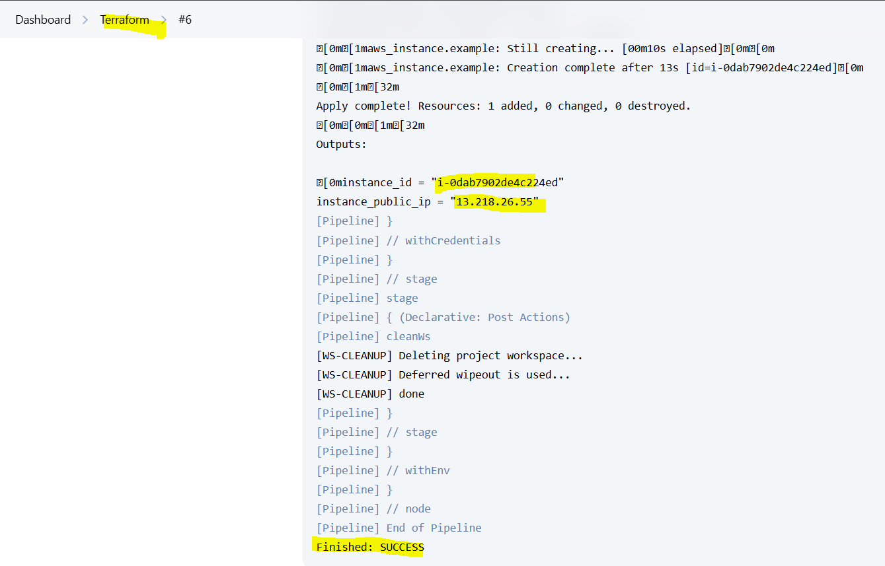
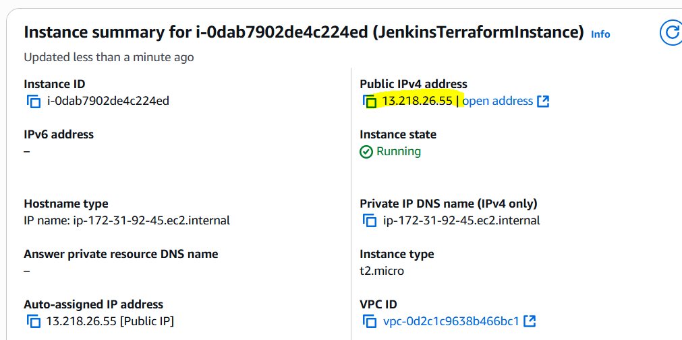

Instances are created Successfully.

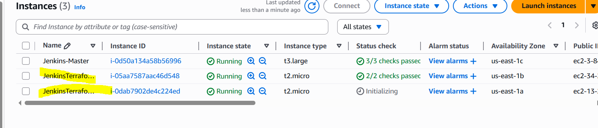

THE-END

